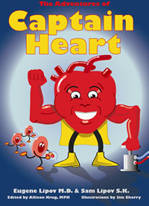
The Adventure of Captain Heart and Friends
Game Design Document
Developed By: Jen Klingberg, Tanner Wilson,
Chris Burton, Jon Antonik, Geoff Adams, and
Christodoulos Papavasiliou
March 19, 2012

Table of Contents
Title 4
Description 4
Purpose 4
High Concept 4
Genre 4
Target Platform 4 - 5
Minimum Specs for Windows 5
Target Audience 5
Rating 5
Player Mode 5 - 6
Time Interval 6
Back Story 6 - 7
Captain Heart 6
Super Brain 7
Character Descriptions 7 - 8
Important Characters 7 - 8
Other Characters 8
Competitive Analysis 8 - 9
Rules 9
The number of player(s) 9
Game Length 9
Victory/Loss Condition 9
Game Play 9
Challenges 10 - 12
Flowchart of mini games 12
Strategies 13
Game Balance 13
Perspective 13
User Interface 13 - 17
Controls 15
Main Menu 16
Main Menu flowchart 17
Audio 17 - 18
Overall Sounds and Music 18
Future Updates 18

Title
The Adventure of Captain Heart and Friends
Description
The Adventures of Captain Heart and Friends - is an educational game all about: learning about certain areas of the body and learning about how to have a healthy body. This game has adventure, mini-games, solving puzzles, and trivia questions about the body. The game is going to be fun, but also packed with healthy tips and strategies. This will lead to an environment that kids will want to explore and learn. Through various mini games and other activities players will simultaneously learn and navigate through the body. The game is aimed to help fight obesity in young children and teach our kids how to stay healthy like Captain Heart.
Purpose
The games main purpose is to educate kids on the importance of a healthy heart. It will teach kids about eating right and being active. It will help fight obesity in young children. This game is expected to be included into many school health programs. By combining fun entertaining mini games with the information presented in the story, the game will be both educational and fun to play.
High Concept
Take fun adventure through the body with Captain Heart and his friends. Go with Captain Heart on a storybook adventure and learn about the heart through exciting mazes, food mix and match game, blood cell run, trivia questions game, and much, much, more.
Genre
Educational Adventure
Target Platform
The target platform will be the PC and Nintendo 3DS. The PC platform version will be released first to the public, with the Nintendo 3DS platform version being released second. The PC platform version will be released into elementary schools for their health programs. The PC platform version will also be released into the market for the public. Different version of the game may be developed for the Nintendo3DS, once the PC version is released. The requirements for this game will be kept to a minimum so that all schools regardless of their computers will be able to add Captain Heart to their classrooms.
Minimum Specs for Windows:
- Windows 7 or higher
- Intel 4100 or better/ or NVIDIA 7800 or better
- Intel Core 2 duo processor 2.0Hz or better
- DirectX 9.0c 64MB video card and drivers
- 384 MB of RAM
- 3.3 GB of uncompressed hard disk space

Target Audience
The targeted audience will be children of ages four and up. We want our game to teach children how to keep a healthy body and we believe that the earlier they learn the better.
Rating
The targeted ESRB rating for our game is 'E' for everyone. The ESRB classifies titles rated 'E' as games that have content that may be suitable for ages 6 and older. Titles in this category may contain minimal cartoon and fantasy. We are aiming for this rating based off of the content and difficulty of the game; which at the request of the client should be focused on children at the age of four or older.
Player Mode
The game will be primarily developed as a single player game that is intended to give players a one on one learning experience. However, some of the mini-games may be designed in order to allow two players to work together to complete a goal. Some of the mini games will also use a score system so kids can compare scores with each other.
Time Interval
The time intervals for this game will vary between situations. For story segments, players will decide how quickly they progress by clicking/pressing a button or prompt. Mini-games will also require different time intervals. For instance, platform mini-games would be in real time. A mini-game that makes use of a different time interval would include a match making game where the computer would provide some form of prompt, and the player would need to act accordingly; this would be an example of a turn-based time interval.
Back Story
Captain Heart
Billy, a young boy of 8 years old, wonders why his Grandpa wasn’t playing as much anymore. His get-up-and-go- got up and went. Billy’s Grandpa was tired all the time. Billy and his Grandpa went to Grandpa’s doctor for a doctor visit. The doctor listened to Grandpa’s heart. Billy asked the doctor “Is Grandpa sick?” “Why doesn’t he have energy?”
“Billy,” the doctor said, “your Grandpa’s heart is not as strong as it should be. I think his blood vessels are clogged and his heart is weak. We need to help his heart turn into Captain Heart who can help Grandpa get strong again!” “How do we do that?” Billy asked in amazement. “I want my Grandpa back so we can play ball!” “Grandpa,” the doctor said, “Your heart problems are caused by the foods you and Billy are eating.”
Billy and Grandpa liked to eat together, but the foods they ate slowed them down. Grandpa was feeling slower than Billy, because he had eating poorly for a longer time. The doctor said junk foods like candy and fries were making their hearts sick. “Without a healthy heart,” the doctor said, “you’ll have no energy!”
That really made Billy wonder, “How does what we eat make our hearts weak?” Captain Heart steps into the room and says, “I can show you when eating bad food can do to your heart and what it takes to have a healthy heart!”
Super Brain
Billy, a young boy of 8 years old, is having trouble remembering things. Billy could not remember letters. He could not read or do math. This made his brain angry and sad.
This made Billy feel very sad and angry. His parents and teachers tried to help. Then he went to visit a special doctor.
The doctor said Billy’s brain was very smart, but his brain was not working well, the doctor suggested some tricks to help his brain work better. He also said “never skip breakfast, the brain needs food to work.” Super Brain walks into the room and says to Billy, “I too can show you all you need to know to get your brain and turn it into a Super Brain.”
Character Descriptions
Important Characters
Captain Heart
Captain Heart is the main character in “The Adventures of Captain Heart.” Captain Heart helps a young boy Billy to understand about the heart and what it does and how to help to keep a healthy heart. Captain Heart-Is a heart just like mine or yours, but is super fit. He is super fit because he knows all about keeping healthy and eating right. Basically he has the overall shape of a heart with some arteries on top like hair. He also has two super buff arms and two legs. He also wears a yellow cape and yellow boots. Captain Heart is the main character that takes the player through the body and shows all what the heart does though the mini games throughout the game.
Super Brain
Super Brain is the main character in “The Adventures of Super Brain.” Super Brain helps a young boy Billy to understand what it takes to have strong memory, to be able to focus in school, and being able to absorb new learning material. Super Brain-Is a heart just like mine or yours, but is super fit brain. He is super fit because he knows all about keeping a healthy and strong brain. Basically he has the overall shape of a round brain. He also has two arms and two legs. He also wears a red cape and black sneakers. Super Brain is the main character that takes the player through steps of learning memory games, exercise, mazes, math, and trivia quizzes to help strengthen the brain in mini games throughout the game.
Other Characters
Billy
Billy is a young boy learning about the body. He goes on these adventures with Super Brain and Captain Heart to learn about these areas of the body. He narrates through the story line in each of these adventures.
Grandpa
Grandpa is Billy’s grandfather who is not feeling well in the Captain Heart game. Grandpa and Billy go to the doctor to find out why Grandpa is not feeling well, and how to make him well again with Captain Heart.
Doctor
The doctor character is the physician who tells Billy the symptoms of what is wrong with his brain and Grandpa’s heart. The doctor character will be in both adventures to gives the symptoms, advice, and introduces the main charters to the game.
Competitive Analysis
Three games that could be competitors to our game would be “Brain Age Academy”, the “My language coach” series, and surprisingly, the Mario Party Series.
- Brain Age Academy offers fun ways to challenge the brain using various fun activities. Our game will also be stimulating the brain as well as teaching the user various fun facts about the human body.
- The “My Language Coach” series is similar to Brain Age Academy, except it teaches the user different languages with easy and goes through various activities at the end of each chapter to help you learn different words in a fun way. As stated earlier, our game will provide fun activities while teaching the user different facts about the body.
- The “Mario Party” series goes through different maps across a giant playing board. Although our game won’t have party events, it will have different places to visit, similar to Mario Party, as well as mini games to play once they’re unlocked.
Rules
The number of player(s)
The Adventure of Captain Heart and Friends is a single player game.
Game Length
The game can be played for approximately 20 to 40 minutes depending on the age. The game will be made up like a story book with different chapters being different segments of the game. Some mini games may have a time requirement, but for the most part the game will be untimed.
Victory/Loss Condition
The game is played in stages and to achieve victory you must complete each stage. Losing condition is when a player is unable to complete the stage and continues to play at that level. There won’t be a game over because the game is meant to be educational so if a child is struggling with a mini game or game concept the game will provide a helpful hint and restart the current level instead of losing.
Game Play
The Game will compose of many different mini games. The game will be broken up into sections to follow the book like chapters. Each chapter has different mini games to go along with the message in the chapter. For instance in one chapter Captain Heart (player) has to match what is considered healthy food to eat. The consequence for eating non-healthy food is that he is unable to proceed to the next stage. Captain Heart (player) scores depend on what choices he/she makes. The game ends when the player is able to progress through the books chapters and successfully complete all the mini games.

Challenges
Some challenges players may face depend on the mini game being played. Some challenges will include:
- Puzzles
- Mazes
- Riddles
- Trivia questions
- Food chooses
- Chapter bosses
Screen Shot of one of the Mini games for Captain Heart
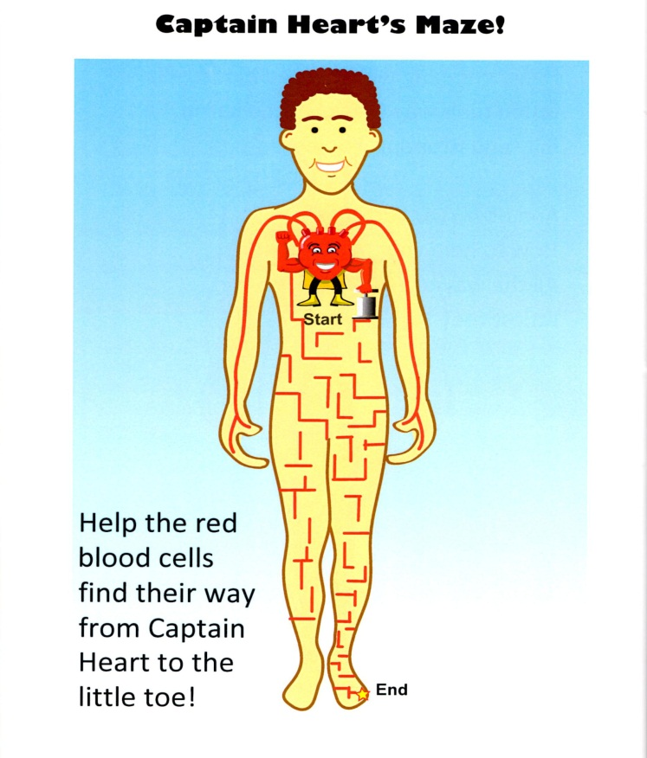
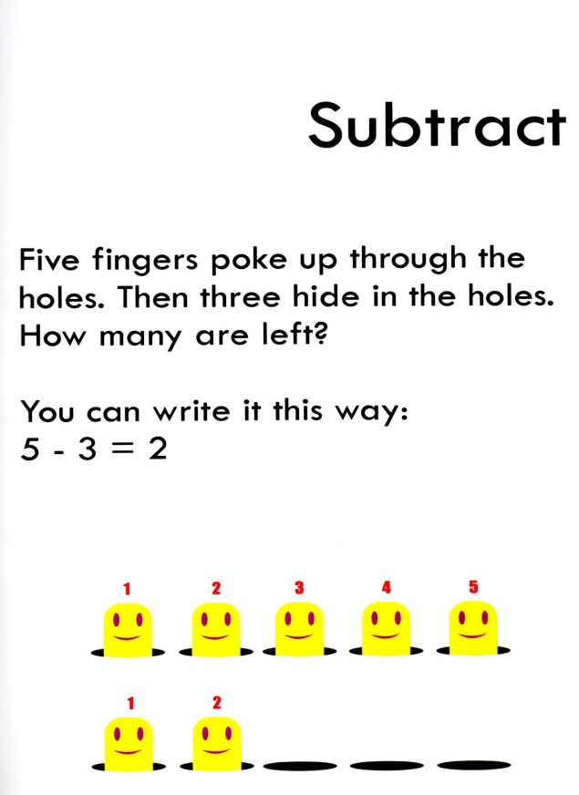
Screen Shot of one of the mini games for Super Brain
Flowchart of mini games for Captain Heart and Super Brain
Strategies
Some of the strategies the players will use during the game will be collecting, exploration, and navigation through parts of the human body. The players will go through various challenges that will help keep a healthy heart. One of the challenges the players will face is to choose and collect healthy and unhealthy foods in order to satisfy Captain Heart. For a different challenge the players will need to clean up the cholesterol from some arteries in order to increase the blood flow.
Game Balance
Since the game will be geared towards younger kids, with our target audience being 4+, the game will be fairly simple. Therefor there will not be a game over but if you are unable to complete a section of the game you will be provided a helpful hint and retry that part. Failing a mini game might be because you choose too many unhealthy foods and didn’t get a high enough score to move on.
Perspective
The game will have two different versions. For the PC version our game will use a third person perspective. All the objects in the game will be in two dimensions and the game view will be side-scrolling. For the Nintendo 3DS version we will be using a third person perspective as well but our graphics will be in three dimensions and the game view will still be side-scrolling. The reason we choose 2D game environment for the PC version is because our target audience are young children and we want to make the game as simple as possible.
User Interface
The players will be able to play the game mainly using the arrow keys on the keyboard and the mouse to navigate. The mouse buttons to perform actions, while moving objects on the screen will be used by the keyboard arrow keys. The user interfaces for the game will be as simple and self-explanatory as possible. We want to make is as easy as possible for our users to play the game and since our targeted audience are children of ages four and up we need to keep everything as simple as we possibly can. At the beginning of the game we will have a very simple menu where the players can choose to start one of the adventure games, to change the options, see the credits, or exit the game. Once the player starts the game there will be a pause button that will bring up a menu to either continue or exit the game.

CONTROLS
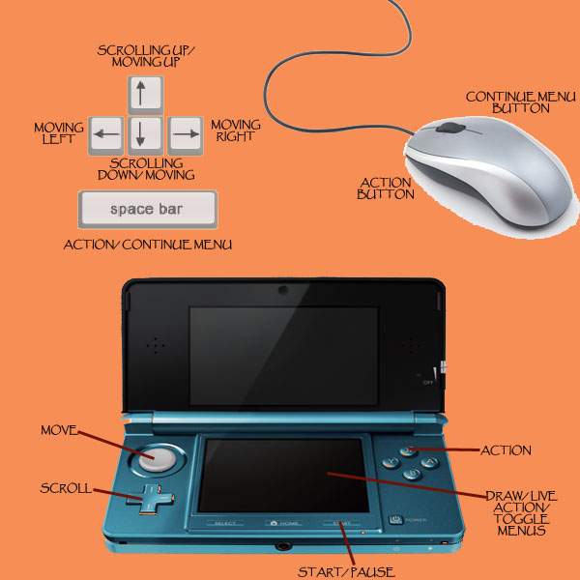

MAIN MENU
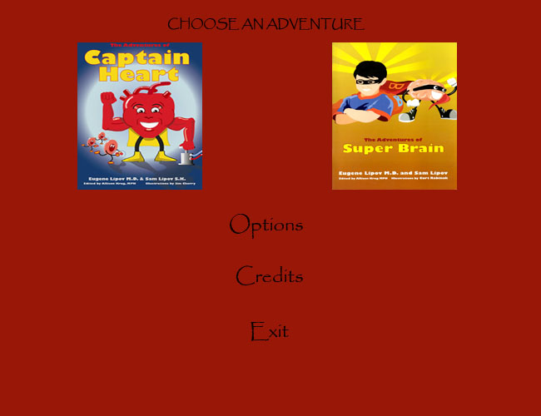
Menu system flowchart
Audio
The audio for this game will have two options that the player can select from in the menu. The audio options are:
- Headset (Binaural)
- Stereo (Transaural Stereo)
The headset option is for the player who needs to have headphones. This option gives a unique sound quality for the player. The headset sounds is a binaural recording which will give the player the feel of the object being right next to them as the player plays the game. The recordings are recorded by ear level, as human would hear these sounds naturally. A 2-channel recording made with an omnidirectional microphone in each ear of a human or a dummy head, for playback over headphones. The object is to duplicate the acoustic signal appearing at each ear. This to give the real affect that the object is playing right next to the player, giving the player the feel that they are in the game.
The stereo option for this game is common in all video games. This option is good for PC and for the Nintendo 3DS, so the player can hear all the sounds and music without using headphones. The audio will be mixed by using a dummy head and placing the microphones near its ears. During the recordings, the signals from a dummy head are processed for playback over loudspeakers, so that acoustic crosstalk around the head is cancelled. This crosstalk is the signal from the right speaker that reaches the left ear, and the signal from the left speaker that reaches the right ear. The net effect is to enable the listener to hear, over loudspeakers. This way gives the player the naturally sounds and clarity to the player while playing the game over speakers for the PC and Nintendo 3DS.

Overall Sounds and Music
The sounds for Captain Heart and Friends should convey of pings, character movement, conversations of charterers, menu clicks, clapping, and simple sounds. Music during the story will be lively, medium tempo, and pleasant. The music during mini games should build tension and excitement.

Future Updates
The future updates will include a 3DS version of the game. There will be two other character books out soon that will produce more games to tie into the Captain Heart universe of educating kids.

