High Concept Document
Jen Klingberg, Jonathan C Antonik, Christodoulos Papavasiliou, Tanner Wilson, Chris Burton
The Adventures of Captain Heart and Friends - is an educational game all about: adventure, mini-games, solving puzzles, and learning about the body (what is healthy and what is not).
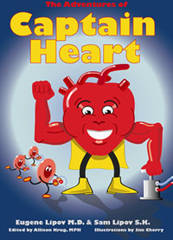
Billy, the main character of this game, is wondering why his grandfather seems so tired all the time. His grandfather has no energy to play with Billy or want to do anything. Billy and his grandfather go to the doctor to find out why Billy’s grandfather seems so tired. The doctor explains to Billy that his grandfather heart is not as strong as it should be. That his blood vessels are clogged and his heart is weak. The doctor then says, “We must turn to Captain Heart to help your grandpa to get strong again!”

The Adventures of Captain Heart and Friends are different than everything else on the market. This is high adventure game that helps young children learn about the body. This game will be unique in the fact that the main character will learn different areas of the body with four adventures games. For this game Captain Heart and Super Brain are introduce only. The first adventure is being Captain Heart. The Adventures of Captain Heart is learning about the heart: how it works, what foods to eat, what foods to avoid, learning what the red blood cells do, and the effects of the heart and how the heart works with the entire body. The Adventures of Captain Heart will go through an adventure story about Billy learning about the heart, it will have interactive mini games like: dragging the right food to Captain Heart to keep Captain Heart healthy (unhealthy food will make Captain Heart ill), putting the red blood cells in the right place, mazes, learning different sizes of hearts, puzzles, pump Captain Heart in order for the body to get blood, speed quiz (how fast can you correctly answer the questions about the heart) and other games in order to find out how the body works with Captain Heart.
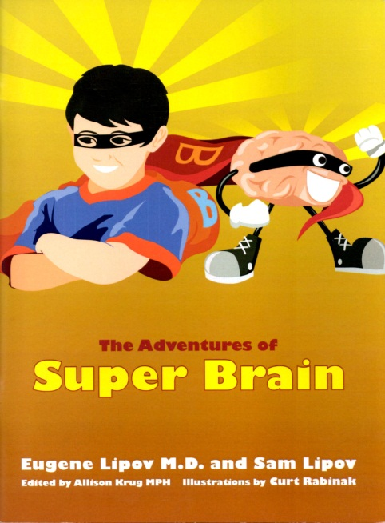
The second adventure is Super Brain and learning how the brain works and functions. Once again the player will go on an adventure with Billy, but to learn about the brain. Billy is introduced to Super Brain in this adventure. The story begins with Billy having a hard time remembering his letters, having a hard time reading and doing his math. He was sent to special doctor who says that Billy’s brain was very smart, but his brain was not working well. The doctor then suggests talking to Super Brain and what Billy’s needs to do in order to have a super brain of his own.
The Adventures of Super Brain is learning about the brain: how it works, what foods to eat, what foods to avoid, exercises, meditation, eating right, sleep, memorization, and how the brain works with the entire body. The Adventures of Super Brain will go through an adventure story about Billy learning about the brain and how it works. This game will also have interactive mini games like: connecting letters to words and objects, memory games, mazes, draw lines around objects to create letters, learning letters, find the hidden object in the picture, math problems (adding, subjecting, multiply, and division), and a speed quiz (how fast can you correctly answer the questions about the brain).

The third adventure is Elastic Skin learning about the skin and how to treat the skin. The fourth and final adventure is Power Colon. This is where Billy learns about the colon and the skin and what is needed to have a healthy colon and skin. All of these adventures will continue to have puzzle, adventures through the body, learning about each of these organs and what they do, how to fight obesity, good foods, and how to avoid bad foods. These adventures will be for a future game.

The Adventures of Captain Heart and Friends are mainly going to be for Nintendo 3DS and PC consoles. This game will be a 2D platform game for the PC. For the mini games part of the game will have a 2D format, with interaction to all the games. The 2D format is to keep the look of the children books and interaction like the book. For the Nintendo 3DS will be very similar to the PC. The objects will be 3D, everything else will remain the same.
The game Controls within this game will be fairly standard – arrow keys will be the basic movement keys, along with the mouse control. The Nintendo 3DS controls will have touch screen controls with stylus as well as D-Pad controls.

This game will be comparable to Early Learning Academy. Where young children can learn about different subjects (arts, math, health, music, etc.) can have story adventures, interaction puzzles, or playable videos about the subject that the child is learning about.

Kids on Keys: is an educational game that young children can learn words, type words, and learn their alphabet. This has multiple mini games like: letter drop, spell the right word for the object, and speed type of the word that was given before the time runs out.

Where in the World is Carmen Sandiego: is an educational game that young children can learn about different facts about place throughout the world. Clues are given throughout the game of possibilities of where Carmen is at and by learning these facts of places throughout the world, the player can catch Carmen.

The age group that The Adventures of Captain Heart and Friends would be most appropriate for would be anywhere from the age group of four through eight years old. That is not to say that older or younger audiences wouldn’t be interested, of course. There are more books that are in the making right now, besides these two adventures currently. This can lead into other games being made for the future with these series of adventures.

